REVA HACK</> 2021

Elevator Pitch

**STARK**

Sowmya Sree T

Raksha R Y

C Sri Sravya

Patron Augury

**12th November, 2021**

# Overview

# The aim of Customer Churn Prediction Model is to detect customers with high tendency to leave a bank.

# Goals

The goal is to calculate the churners of a bank so that they can improve themselves by taking the help of machine learning algorithms and python libraries.

# Working Methodology (Summary on how your project is going to work/solve the problem stated)

1. Build a model using customer churn prediction rate

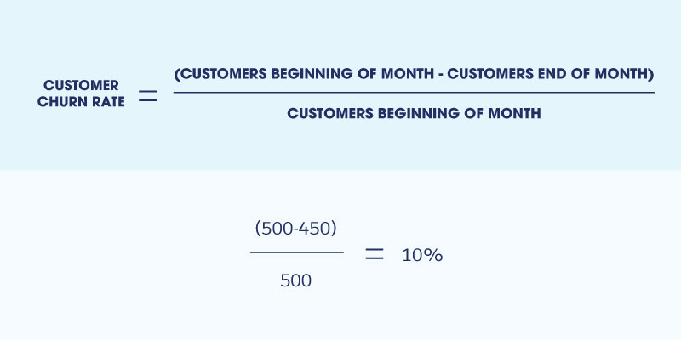

1. Analyze and categorize the data (collected from Kaggle data set) using visualization libraries and random forest algorithm using machine learning.

# Specifications (Tech Stack Used - Hardware + Programming Languages)

We used

* Random Forest Algorithm
* Python programming language
  + NumPy
  + Pandas
  + Matplotlib
  + Seaborn

# Links and other Information:

<https://github.com/SowmyaSreeT/Patron-Augury>

https://devfolio.co/project/submit